**USER MANUAL**

1. **PacGame**
   1. **Characters**
      1. **PacMan**
      2. **Ghost**
         1. **Sam**
         2. **Cam**
         3. **Danny**
   2. **PacWorld**
      1. **PacDots**
      2. **PowerPellets**
   3. **PacGame**
2. **MouseGame**
   1. **Characters**
      1. **MouseHero**
      2. **Mouse**
   2. **MouseLand**
      1. **MouseTrap**
      2. **Exit**
   3. **Game Play**
3. **PipeGame**
   1. **“Characters”**
      1. **Plumber**
      2. **Water**
   2. **PipeMap**
      1. **Pipe**
   3. **PipeGame**

**4. Engine**

**4.1. Classes**

**4.2. Game Play**

**1. PacGame**

Based on the original ‘PacMan’, PacGame is a tile based and slow-motion type game which requires the character, PacMan, to collect all the PacDots on the grid, while avoiding or killing Ghosts.

**1.1. Characters**

The characters are basic. The hero is PacMan, the enemies and Non Player Characters (NPCs) are the Ghosts.

**1.1.1. PacMan**

PacMan is the hero of this game. He is controlled by the user and is followed by the ghosts. PacMan eats PacDots to gain points and to complete the game, and may also eat PowerPellets to become invulnerable and thus gain the ability to eat ghosts.

**1.1.2. Ghost**

PacGame has a population of Ghosts that are set out to catch and kill PacMan. In order to effectively do this, each Ghost has its own personality, characterized in the original PacMan. The names of these ghosts are Blinky, Pinky, Inky and Clyde (source: http://en.wikipedia.org/wiki/Pac-Man). In this version, there are only three ghosts, with slightly distinct personalities (**not implemented yet**).

**1.1.2.1 Sam**

Sam is the sceptical Ghost, characterized by its (:S) face. It is always contemplating possible moves in order to cut off PacMan. You could say he is the smartest ghost of all and he is most likely to trap PacMan, along with the help of his other Ghost friends.

**1.1.2.2 Cam**

Cam is the sad ghost, characterized by its ☹ face. Its sole purpose is to trail PacMan in the hopes that PacMan will one day take a wrong step backwards into the stomach that is has been left empty for so long.

**1.1.2.3 Danny**

Danny is the happy ghost, characterized by its (:D) face. It has no sense of purpose and randomly travels the grid at its leisure. There is no way to predict its next move.

* 1. **PacWorld**

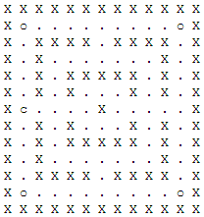

PacWorld is composed of Walls and PacDots. In this textual representation, ‘**X’ symbolizes a Wall**, **‘.’ represents a PacDot** and ‘**o’ represents a PowerPellet**. The **c** shown here is the starting position of pacman.

**1.2.1. PacDot**

The PacDots feed PacMan points, and if all of them are collected, the game is won. **Each PacDot is worth 10 points**.

**1.2.2. PowerPellet**

The PowerPellet makes PacMan **invulnerable for the following 10 turns**. While invulnerable, PacMan can eat Ghosts. The Ghosts that are eating will not return for the duration of the game. Ghosts should flee pacman while he is invincible (**not implemented yet**). After 10 turns, PacMan is vulnerable again and must avoid ghosts.

* 1. **Game Play**

The initial screen of the text based game is the following:

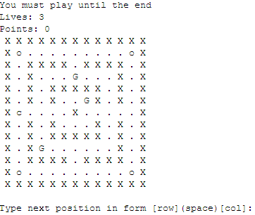

This screen states that the game does not end until either PacMan loses all of his lives, or until all the PacDots are collected. The input required is [row](space)[column], which will compute the best movement direction based on the given position. For example, if the first position given is ‘6 6’, the PacMan will move towards the middle of the board.

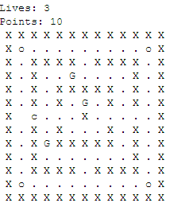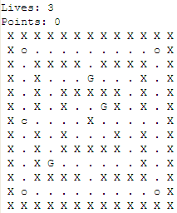

‘6 6’ ->

If no move can be computed from given position, the game will let you know. Refer to *Section 4.1.* to understand how the engine computes adjacent moves given a position.

**2. MouseGame**

MouseGame is a Tile based game and requires you to take your Hero Mouse called Cheesy and get through the maze to a finish point, while all the other evil mice’s try to catch you. Cheesy has some help, because he can drop a mouse trap whenever he wants to at the location he is at but he only gets ONE mouse trap.

**2.1. Characters**

The characters are basic. The hero is a mouse called Cheesy, the enemies and Non Player Characters (NPCs) are mice called Red-Eyes.

**2.1.1. MouseHero**

Cheesy is the hero of this game and is trying to reach the finish line at the other end of the maze. But it is not simple because Cheesy is being chased by evil mice called Red-Eyes. In his favour he can drop a mouse trap at his position whenever he feels like it is useful; the mouse trap will eliminate the Red-Eyes.

**2.1.2. Mouse**

The Red-Eye’s goal is to try to catch Cheesy, they do so by always going to the last position Cheesy has been. It seems pretty easy, but when you are cornered you have no way out.

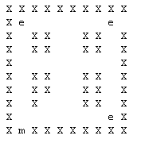 **2.2. MouseLand**

MouseLand is composed of Walls and blank Tiles. In this textual representation, ‘**X’ symbolizes a Wall** and **where there is nothing are the blank tiles**.The ‘**m’** shown here is -the starting position of Cheesy. The ‘**e’** are all the Red-Eye’s trying to catch you. The image shown here is the starting position of the MouseGame.

**2.2.1. MouseTrap**

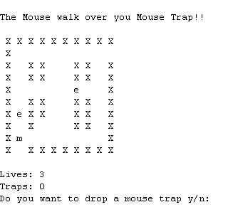The mouse trap is shown by the character ‘**T**’ and does not move or do anything until a Red-Eye walks over it. When that happens **BOTH** the Red-Eye and the mouse trap will disappear.

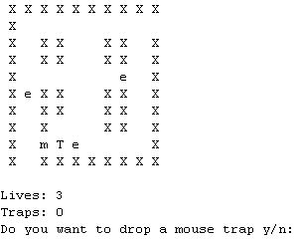

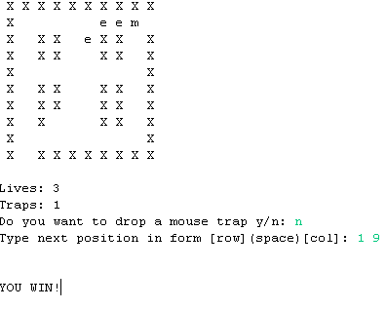**2.2.2. Exit**

The Exit point as you can see is on the top right of the board where there is a space between the walls. Once you have entered your next position and it is row 1 and column 9 and you are only one spot away you win the game.

**2.3. Game Play**

Here is the **initial screen of the MouseGame.** You are then asked if you want to drop a mouth trap or not, all you have to do it type in **‘y’** if you want to drop a mouse trap, if you don’t want to you can type in **anything** else.

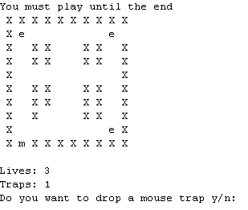

Then you are asked to type in the **row and column** you want Cheesy to move. The very 1st position has to be of row 1, and example can be“1 1”... (It goes “number (space) number”) and will keep asking for your inputs until you are caught by a Red-Eye (which then the game restarts and you have one less life) or you reach the exit point. If Cheesy is caught, the number of Red-Eyes and mouse traps remain the same number as the previous stage. So if you used your mouse trap and eliminated a Red-Eye then you were caught by another Red-Eye. Everyone will go back to their original positions without a mouse trap and without the Red-Eye that was eliminated.

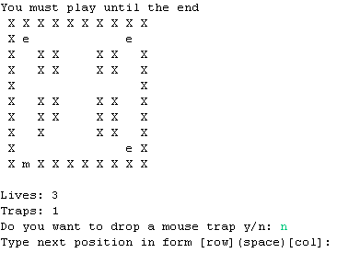You do not have to type in the exact Tile that cheesy will be going on next, as long there is a clear path to that tile without having a wall in the way he will go. **(See 4.2 for more explanation).**

**3. PipeGame**

**3.1. “Characters”**

**3.1.1. Plumber**

**3.1.2. Water**

**3.2. PipeMap**

**3.2.1. Pipe**

**3.3. PipeGame**

**4. Engine**

The engine describes the generic functionalities that all games may choose to use or overwrite. It contains basic classes and methods that match typical behaviour in a tile based game.

**4.1. Classes**

The classes provided by the engine are Board, Tile, Avatar, Hero, NPC, Item and Wall.

**4.1.1. Board**

The board is where the game is played. There is a method provided that carries out a typical turn, given a Position. This method moves the Avatar based on the given position, than moves the NPC’s based on the Avatar’s position. Each game board is responsible for setting up the layout of the [item] Map prior to initializing a game.

**4.1.2. Tile**

Everything that is placed on the board is a Tile. The Tile is the superclass for any all other classes that are present on the board. The Tile class also represents an empty space on the map.

**4.1.2.1. Avatar**

Avatar is everything that can move on the board. It is the superclass to Hero and NPC and contains methods are used to react to items on the board or how they move.

**4.1.2.1.1. Hero**

Hero is the user controlled Avatar that has a specific goal to accomplish.

**4.1.2.1.2. NPC**

NPC is the AI based Avatar that generally gets in the way of the Hero’s goal

**4.1.2.2. Item**

Items are initially placed on the map, and removed as they are picked up. They generally have consequences such as increasing points, killing Avatars, or other creative purposes.

**4.1.2.3. Wall**

A wall should not be accessed by Avatars unless specifications declare otherwise. They serve to create a maze like feel in a game.

**4.2. Game Play**

All tile based games using this engine use click-move functionality. For the most part, this involves clicking anywhere on the map, resulting in the movement of Avatars based on the position of the clicked tile.

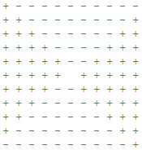 **4.2.1. Typical Movement**

In the majority of games, the movement of the avatar is one space to the North, South, East or West direction. If the user clicks on a tile that does not lie within this one space limit, the engine will compute what is assumed to be the desired direction. The grid on the right illustrates how the engine determines the direction. The Hero lies in the middle of the grid, and upon clicking inside the + region, it will move either left or right, if there is no Wall where it is to go. The – region will move the Hero either upwards or downwards. This allows the user to spend less time choosing which tile to click.